Excersize sheet 02:
  - parent(a,b) <-
female(a) <-
male(a) <-

aunt(x) <- sibling(x,y) ^ parent (y,z) ^ female(x)
sibling(x,y) <- parent(z,x) ^ parent(z,y)
uncle(x) <- sibling(x,y) ^ parent (y,z) ^ male(x)
grandmother(x) <- female(x) ^ parent(x,y) ^ parent(y,z)
ancestor(x) <-

  - aunt(x) <- sibling(x,y) ^ parent (y,z) ^ female(x)
aunt(x) <- female(x) ^ married(x,y) ^ uncle(y)

uncle(x) <- sibling(x,y) ^ parent (y,z) ^ male(x)
uncle(x) <- male(x) ^ married(x,y) ^ aunt(y)

2.1 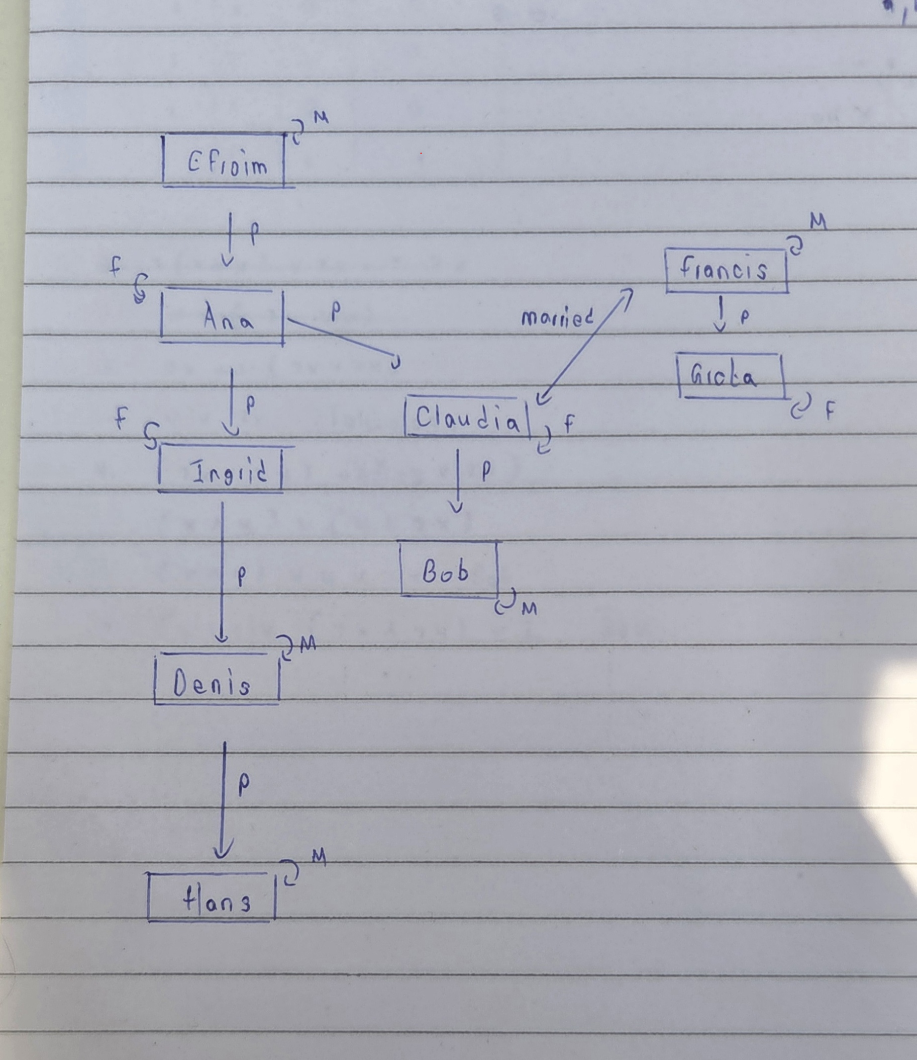 Note that sibling, aunt,uncle should be mentioned as well.
2.2 Efraim is ancestor of denis
Efraim not ancestor of greta
Francis not uncle of bob
Francis is uncle of denis
Ana, Ingrid are grandmothers
Claudia and Ingrid are siblings

3.1 It is possible to make a model with 7 elements. Since the canonical model has 9 elements we need to remove two elements.
A model will less elements is a weaker model.
Here we can remove denis and Hans and squeeze them together with Ingrid
New domain will be {a,b,c,d,e,f,g}
New interpretation is Denis I = I and Hans I = i
Note that we can do this and map ancestor to itself, there is no restraint saying I cannot be male and female at the same time.
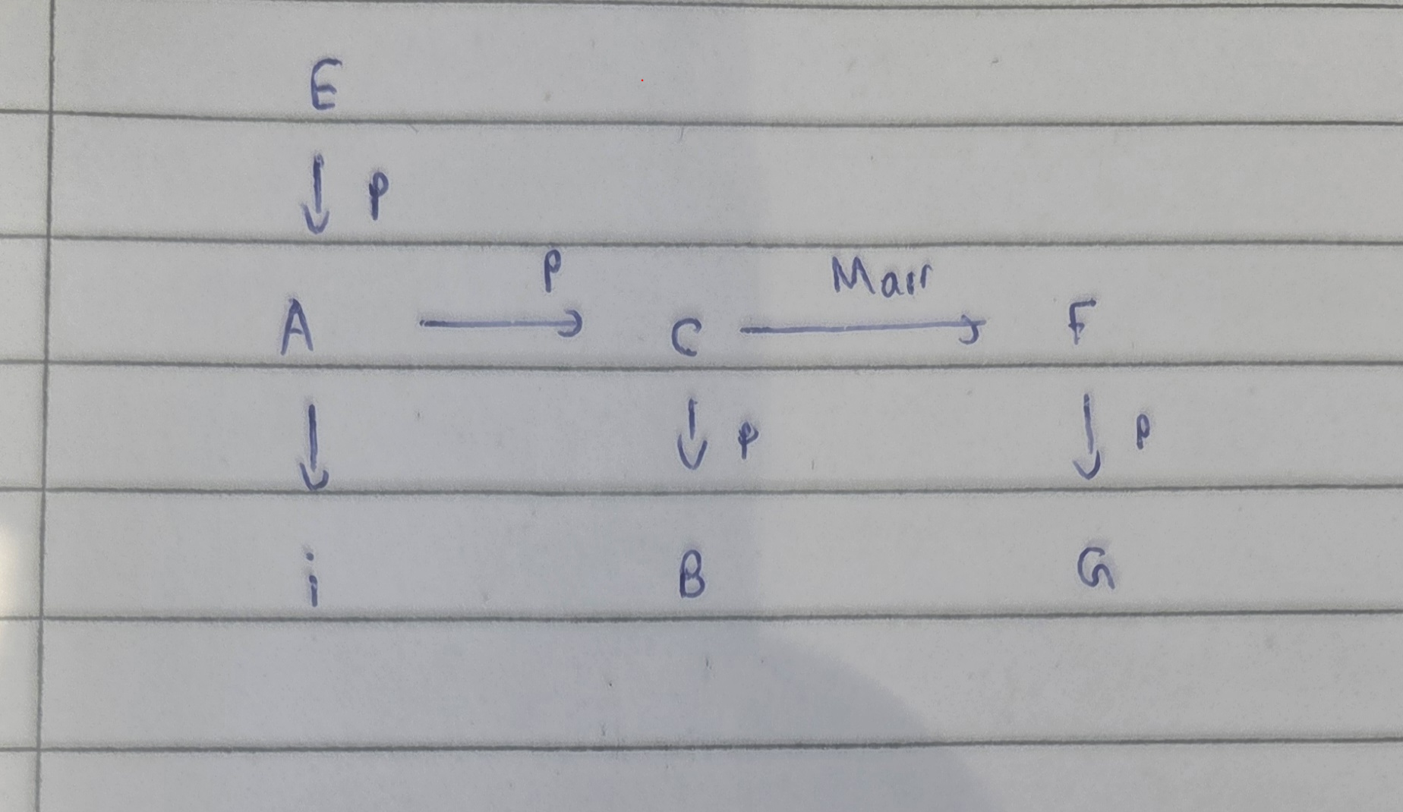
3.2

4.1 A model is an interpretation that satisfies all the rules, every set of predicate rules are consistent since every KB is consistent given that they all have a canonical model.
4.2 There can always be a model with one element, there is no limitation however the smaller the number of elements the weaker the model.
I = ({§}, . I )
. I represents the intepretation function where b I = §
c I = §
This kind of model is useless for reasoning

5.1 We need to create a KB with 4 facts and 1 rule
|§| = 4 but |§.§| = 16 therefore we need a rule with a binary predicate

P(a) <-
P(b) <-
P(c) <-
P(d) <-
Q(x,y) <- p(x), p(y)

5.2 Canonical model is such that
Q(a,a) Q(a,b) Q(a,c) Q(a,d) Q(b,a) Q(b,b) Q(b,c) Q(b,d) Q(c,a) Q(c,b) Q(c,c) Q(c,d) Q(d,a) Q(d,b) Q(d,c) Q(d,d)
6. When searching for such an entailment we add a new constant c into the KB and assert q(c)
Given that we cant to check entailment for p(x) <- q(x)
Then we Create the canonical model including q(c) and this would result in a new model,
If this model entails p(c) then it is entailed otherwise we have found its countermodel.

7. The Disjoint union is where we take two inepretations I and J and exists an intersection of the two intepretations. It’s the graph obtained by putting together the graphs of I and J.

8.1 We need a constraint to show someone cannot be there own sibling
<- sibling(x,x)
Also that no one is a parent of themselves, or not male and female at the same time.
8.2 This creates lots of changes
9.1 